**MINAHIL QADIR**

**BSAI-3A(047)**

**TASK 3:**

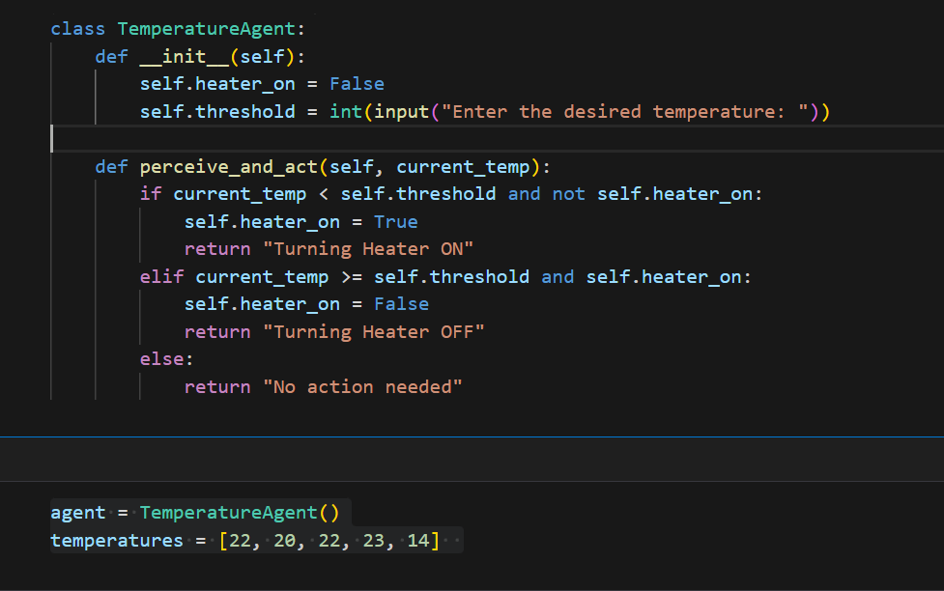

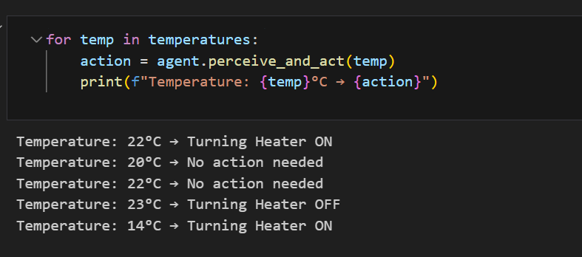

The TemperatureAgent monitors temperature and controls a heater based on a user-defined threshold.

The user sets a desired temperature when the agent is created.

perceive_and_act(current_temp) checks the temperature:

If it's below the threshold, the heater turns ON.

If it's at or above the threshold, the heater turns OFF.

If no change is needed, it does nothing.

A list of temperatures is processed, and the agent decides actions for each one.